**LIT TRAINING**

**Batch Name - SAP ABAP - 25                                                            DAY 14 ASSIGNMENT**

**EMPLOYEE ID – 46247689**

**CDS-Assignment 1 – Create a Simple CDS view with Date Functions in ABAP CDS Views**

**Tables involved – VBAK**

**@AbapCatalog.sqlViewName: 'ZYNY_SQL_VIEW'**

**@AbapCatalog.compiler.compareFilter: true**

**@AbapCatalog.preserveKey: true**

**@AccessControl.authorizationCheck: #NOT_REQUIRED**

**@EndUserText.label: 'CDS VIEW WITH DATE FUNCTIONS'**

**define view ZYNY_CDS_VIEW as select from vbak {**

**vbeln as Sales_Document,**

**auart as Sales_Document_Type,**

**audat as Document_Date,**

**vdatu as Requested_delivery_date,**

**DATS_DAYS_BETWEEN(audat, vdatu) as no_of_days,**

**DATS_ADD_DAYS(vdatu, 10, 'NULL') as shipping_date,**

**DATS_ADD_MONTHS(vdatu, 2, 'NULL') as billing_date**

**}**

**OUTPUT:**

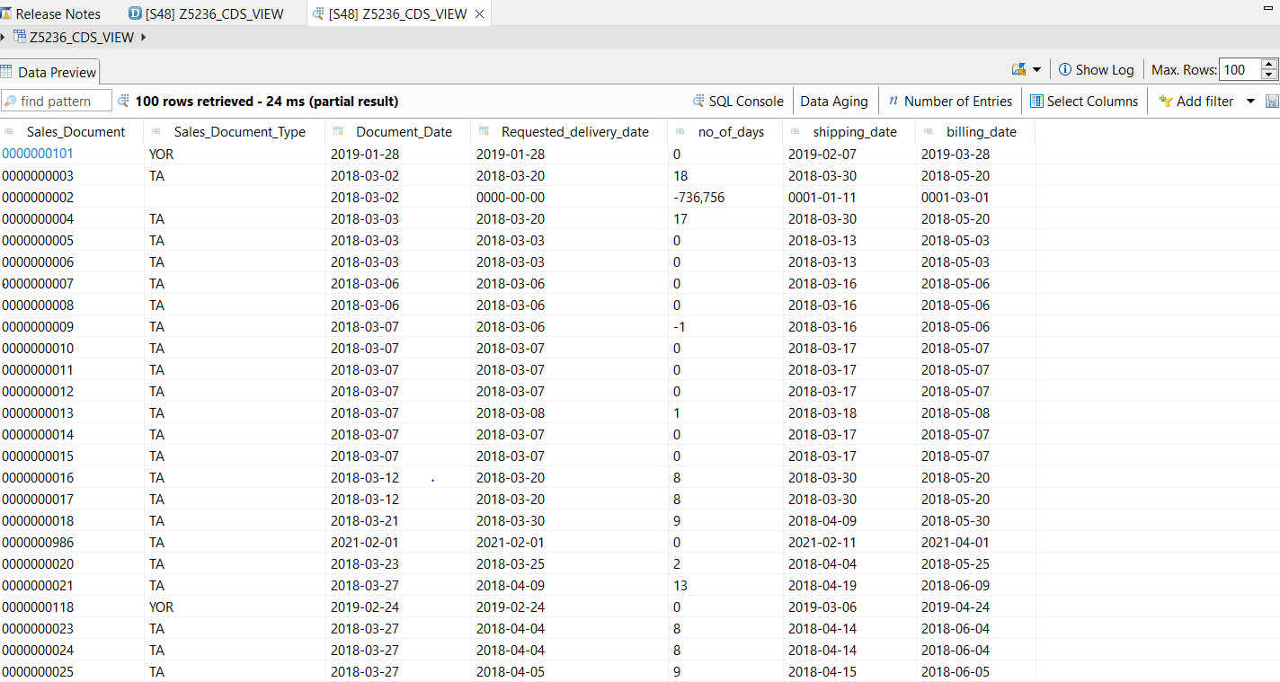

**CDS-Assignment 2 – Create a Simple CDS view with String Functions in ABAP CDS Views**

**@AbapCatalog.sqlViewName: 'ZYNY_STR_FN_VIEW'**

**@AbapCatalog.compiler.compareFilter: true**

**@AbapCatalog.preserveKey: true**

**@AccessControl.authorizationCheck: #NOT_REQUIRED**

**@EndUserText.label: 'CDS view with String Functions'**

**define view ZYNY_CDSVIEW_STRING_FN as select from kna1 {**

**kunnr as Customer_Number,**

**land1 as Country_Key,**

**concat(kna1.name1 , kna1.name2) as concat_fields,**

**concat_with_space(stras,ort01,2) as con_space ,**

**left(name1,2) as no_of_char_left,**

**right(kna1.name1,3) as no_of_char_right,**

**length(telf1) as no_of_char,**

**substring(name1,2,4) as char_str,**

**ltrim(kunnr, '0') as rem_zeros,**

**rtrim(telf1,'4') as rem_last_char**

**}**

**OUTPUT:**

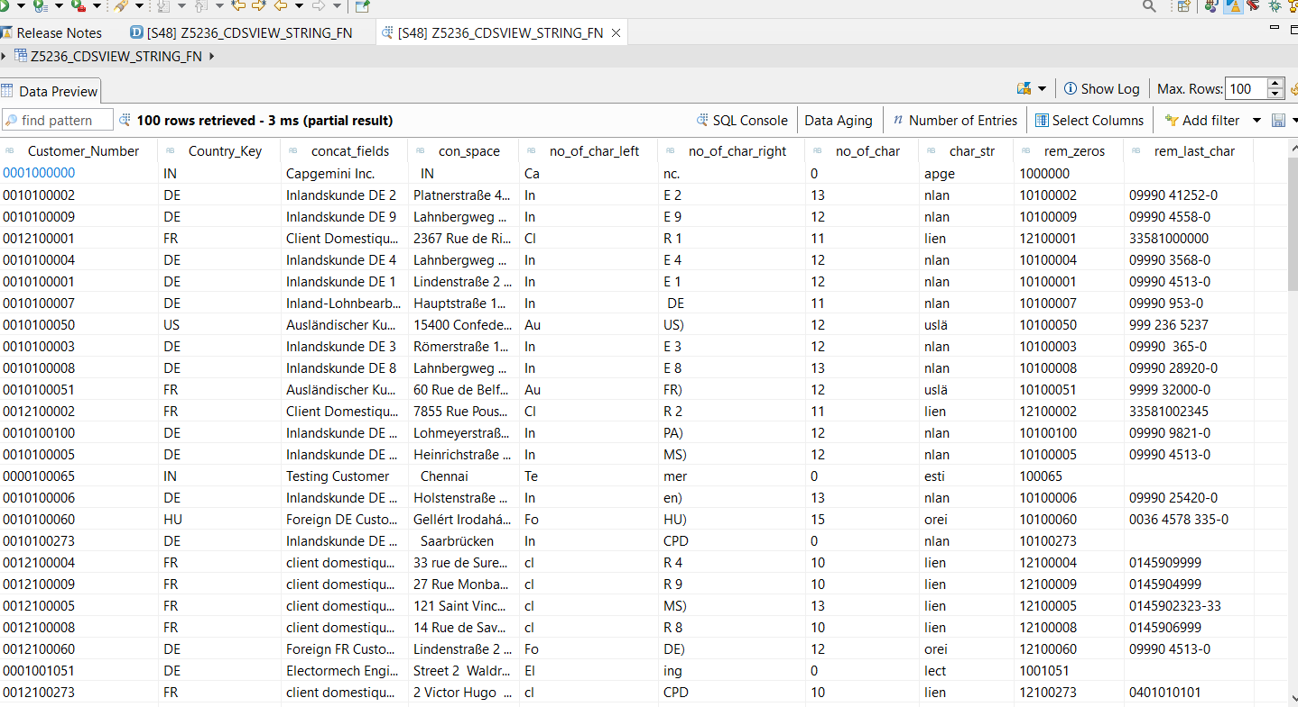

**CDS-Assignment 3 – Create a Simple CDS view with Parameters**

**Scenario –**

* **Create a CDS view with GL currency (PSWSL) as parameter and get the entries form BSEG**

**Tables involved – BSEG**

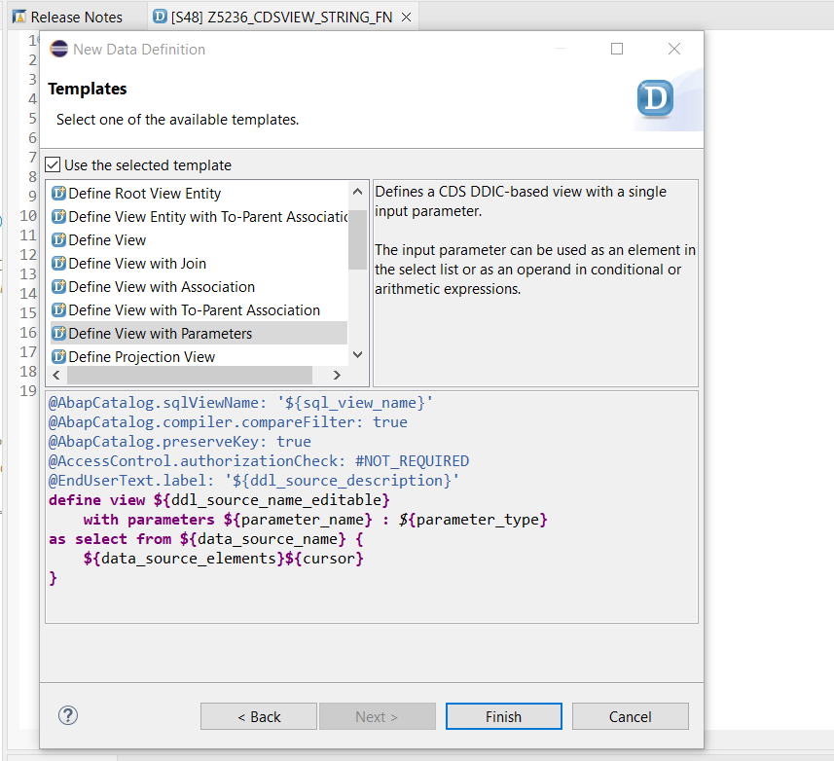

**@AbapCatalog.sqlViewName: 'ZYNY_SQL_VIEW1'**

**@AbapCatalog.compiler.compareFilter: true**

**@AbapCatalog.preserveKey: true**

**@AccessControl.authorizationCheck: #NOT_REQUIRED**

**@EndUserText.label: 'CDS view with Parameters'**

**define view ZYNY_CDSVIEW_PARA**

**with parameters in_curr : *abap*.*cuky*(5)**

**as select from bseg{**

**bukrs,**

**belnr,**

**gjahr,**

**buzei,**

**augdt,**

**pswsl**

**}where pswsl = $parameters.in_curr**

**output:**

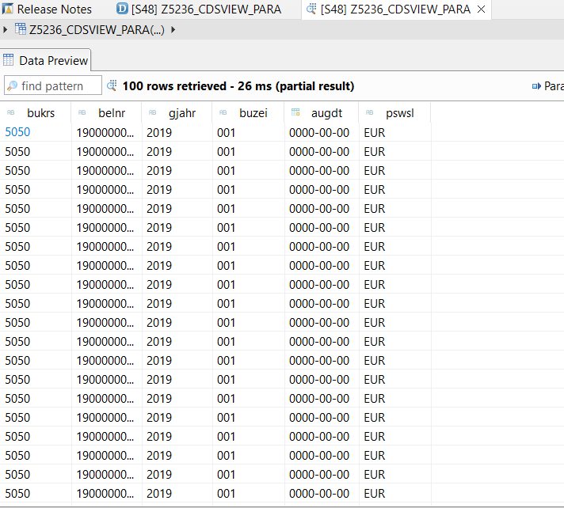

**AMDP-Assignment 1 – Procedures - create a basic procedure to fetch data with scalar variable**

**Scenario –**

* **Print Sales Order number, Material Number, Quantity from VBAP table using scaler variable**

**Tables involved – VBAP**

**CLASS zYNY_amdp_scal DEFINITION**

**PUBLIC**

**FINAL**

**CREATE PUBLIC .**

**PUBLIC SECTION.**

**INTERFACES :IF_AMDP_MARKER_HDB.**

**METHODS: get_vbap_data**

**EXPORTING VALUE(lt_VBAP) TYPE ZYNYTTSTU_VBAP.**

**PROTECTED SECTION.**

**PRIVATE SECTION.**

**ENDCLASS.**

**CLASS zYNY_amdp_scal IMPLEMENTATION.**

**METHOD get_vbap_data BY DATABASE PROCEDURE FOR HDB LANGUAGE**

**SQLSCRIPT OPTIONS READ-ONLY**

**USING VBAP.**

**lt_vbap = select vbeln,matnr,ZMENG from vbap;**

**endmethod.**

**ENDCLASS.**

**REPORT:**

**REPORT zYNY_amdp.**

**zYNY_amdp_scal=>get_vbap_data( IMPORTING lt_vbap = DATA(ex_data) ).**

**TRY.**

**CALL METHOD cl_salv_table=>factory**

**IMPORTING**

**r_salv_table = DATA(lr_salv)**

**changing**

**t_table = ex_data.**

**CATCH cx_salv_msg.**

**ENDTRY.**

**lr_salv->display( ).**

**OUTPUT:**

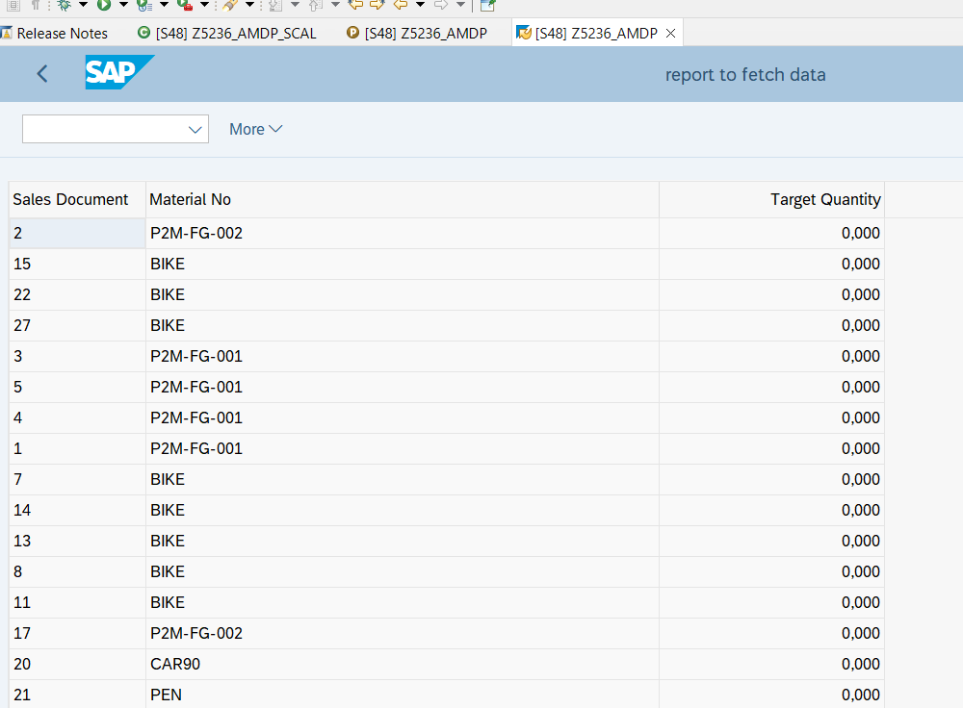

**AMDP-Assignment 2 – Procedures - create a basic procedure with Table**

**Scenario –**

* **Select VBELN, VKORG, MATNR, MENGE from VBAK and VBAP and display the data using table based on material (MATNR).**
* **MATNR will be input field**
* **Do inner join**

**Tables involved – VBAK, VBAP**

**CLASS zYNY_amdp_join DEFINITION**

**PUBLIC**

**FINAL**

**CREATE PUBLIC .**

**PUBLIC SECTION.**

**INTERFACES : IF_AMDP_MARKER_HDB.**

**CLASS-METHODS:GET_DATA**

**IMPORTING VALUE(IM_MATNR) TYPE VBAP-MATNR**

**EXPORTING VALUE(ET_RES) TYPE ZYNYTTSRU_IN.**

**PROTECTED SECTION.**

**PRIVATE SECTION.**

**ENDCLASS.**

**CLASS zYNY_amdp_join IMPLEMENTATION.**

**METHOD get_data BY DATABASE PROCEDURE FOR HDB LANGUAGE**

**SQLSCRIPT OPTIONS READ-ONLY**

**USING VBAP VBAK.**

**ET_RES = SELECT A.VBELN,**

**A.VKORG,**

**B.MATNR,**

**B.ZMENG**

**FROM VBAK AS A**

**INNER JOIN VBAP AS B**

**ON A.VBELN = B.VBELN;**

**ENDMETHOD.**

**ENDCLASS.**

**REPORT:**

**REPORT zYNY_amdp_join.**

**PARAMETERS: S_MATNR TYPE VBAP-MATNR.**

**zYNY_amdp_join=>get_data( EXPORTING IM_MATNR = S_MATNR**

**IMPORTING ET_RES = DATA(EX_RES) ).**

**TRY.**

**CALL METHOD cl_salv_table=>factory**

**IMPORTING**

**r_salv_table = DATA(lr_salv)**

**changing**

**t_table = ex_res.**

**CATCH cx_salv_msg.**

**ENDTRY.**

**lr_salv->display( ).**

**OUTPUT:**

